Luis Ruiz

Assignment 2

CPE 301 – 1001

1. **PART 0**

This assignment took me about 3 hours to do, I had to modify my code quite a bit and generating flow charts always take me a good hour.

1. **PART A**

**DA2_1: Assembly No Interrupt**

This assembly code generates a clock with a period of about 0.5 second at 50% duty cycle. The clock toggles at every 0.25 sec from LOW to HIGH. Aside from generating a clock the, the code has a count that is being outputted to PORTD, I do realize the homework says to output to PORTB; however, my development board on PORTB only has 5 pins. In addition to outputting the count to PORTD, PORTC has few outputs as well, where PORTC.0 is the clk, PORTC.4 is a signal that toggles every 5 rising edges, and PORTC.5 is a signal that toggles every 10 rising edges. The code consists of a loop that loops forever and a loop that generates a delay for the clk that I am generating. After the delay portion is where I output my count to PORTD and the signals to PORTC of course what gets outputted depends if the clk recently hit a rising edge of falling edge. The signals excluding the clk are displayed on a led bar where the clk is displayed on a separate LED.

**DA2_2: Assembly with Interrupts**

The assembly code with Interrupts is very similar to the code described above, the most significant difference is that this code uses interrupts. Before I move on I would like to mention that both assembly codes use a pre scalar of 1024 generating a clock rate of 7.81 kHz. Moving forward, this code starts off similar to the code above except instead of manually polling the flag, I enable global interrupts and an allow forever loop to generate interrupts. Of course I enable Timer0 and global interrupts before entering the forever loop. Once an interrupt is generated the interrupt service routine (ISR) is called; once in the ISR we basically do the same as the assembly code above, it updates my count, toggles a few signals and outputs them. To recall we output the count to PORTD and the other signals to PORTC.0, PORTC.4, and PORTC.5. Just a note PORTC.4 is the signal that gets toggled every 5 rising edges and PORTC.5 is the signal that gets toggled every 10 rising edges, I did this because my development board doesn’t have a PORTC.6.

**DA2_3: C/C++ No Interrupt**

This code like the two above assembly code, it generates a clk and outputs a count every rising edge of the clk. However, this code is written in C instead of assembly which makes a little bit neater to read. Continuing with the discussion the code enables Timer0 with a pre scalar of 1024 after doing this we go into a loop that generates a delay in order to have 0.5 sec delay. The loop that generate the delay is a nested for loop that is used to generate 1953 clock cycles before toggling the clk. I basically translated the assembly code with no interrupts into this C code with no interrupts.

**DA2_4: C/C++ with Interrupts**

Like before this C code is a translation of the assembly code with interrupts. They both have the same flow to them, the only difference is the language in which they were written in. Aside from that this code like every other one outputs a count to PORTD and signals that toggle to PORTC. It has loop that goes forever in order to generate an interrupt and then go in to the ISR function which within generates a delay and outputs given signals. This is done over and over until the user terminates the program and or erases the program off the chip.

**PART B**

**DA2_1: Assembly No Interrupt**

;

; DA2_1.asm

;

; Created: 2/7/2017 5:36:18 PM

; Author : Luis

;

.CSEG ;Code Segment

;DEFINE REG'S AND SOME CONST

.DEF COUNT = R16 ;Define Count as R16

.DEF COUNT5 = R17 ;Define Count5 as R17

.DEF COUNT10 = R18 ;Define Count10 as R18

.EQU FIVE = 0x05 ;FIVE = 5

.EQU TEN = 0x0A ;TEN = 10

.DEF CLK = R19 ;Define CLK as R19

.DEF PC_5 = R20 ;PB5 will be used to toggle PC.5

.DEF PC_6 = R21 ;PB6 will be used to toggle PC.6

.DEF ZERO = R2 ;Define Zero as R2

main:

CLR CLK ;R19 = 0

CLR ZERO ;R2 = 0

CLR R23 ;R23 = 0

LDI R22, 0XFF ;R22 = 0b1111_1111

OUT DDRD,R22 ;PD.0-7 are set as outputs

LDI R22, 0X31 ;R22 = 0b0011_0001

OUT DDRC, R22 ;PC.5 and PC.4 are set as outputs

FOREVER:

OUT TCNT0, ZERO ;Load Timer0 = 0

OUT TCCR0A, ZERO ;Timer0: normal mode, internal clock

;Timer0: enabled, CLk(i/o)/1024

LDI R23,(1<<CS00)

ORI R23, 0X04

OUT TCCR0B, R23

;Create nested loop with the outer loop being similar to

;for(int i = 0; i < 7; i++)

;the inner is a counts up till 255 till exiting

CLR R26 ;R26 = 0

LDI R24, 7 ;R24 = 7

DELAY: ;do{

OUT TCNT0,ZERO ;Load Timer0 = 0

CALL AGAIN_LOOP ;Loop used to count for overflow

INC R26 ;R26 = R26 + 1

CP R26, R24

BRLT DELAY ;}while(R26<7);

;Another small delay to aquire a 0.25sec delay

;more accuratley

LDI R26,95 ;set the TCNTO to 95

OUT TCNT0,R26

DELAY2: ;do{

IN R25,TIFR0

SBRS R25,0 ;check if TOV0 is set

RJMP DELAY2 ;while(TCNT0 < 255)

;Disable Timer and Clear the TOV0 flag

LDI R25, (1<<TOV0)

OUT TIFR0,R25

CLR R25 ;R25 = 0

OUT TCCR0B, R25 ;Disable Timer0

;Change the CLK

LDI R25, 0XFF ;R25 = 255

EOR CLK, R25 ;toggle the pulse

;Check if the clock is Posedge/Negedge

CP CLK,ZERO

BREQ NEGEDGE ;Branch if CLK == 0

;increment counter

INC COUNT5

INC COUNT10

;call the function

CALL CHECK_TOG_5

;call the function

CALL CHECK_TOG_10

;OUTPUT TO PORTC

CLR R25 ;CLEAR R25

;R25 bit 0 is set since CLK did a posedge

ORI R25, 0x01 ;R25 = 0b0000_0001

OR R25, PC_5 ;R25 = 0b0001_0001

OR R25, PC_6 ;R25 = 0b0011_0001

OUT PORTC, R25 ;OUTPUT TO PORTC

INC COUNT ;COUNT++

OUT PORTD,COUNT

NEGEDGE:

IN R25, PORTC

LDI R26, 0x01 ;EXOR PORTC.0 which represents the clock

EOR R25, R26

OUT PORTC, R25 ;OUTPUT TO PORTC

RJMP FOREVER

end:

rjmp end

;~~~~~~~~~~~~~~~~~~~~~~~~~~~~~~~~~~~~~~~~~~~~~~~~~~~~~~~~~~~~~~~~~~~~~~~~~~~~

;~~~~~~~~~~~~~~~~~~~~~~~~~~~~~~~~~~~~~~~~~~~~~~~~~~~~~~~~~~~~~~~~~~~~~~~~~~~~

;FUNCTIONS

CHECK_TOG_5:

LDI R25,FIVE ;if(!(COUNT5 == 5))

CP COUNT5,R25 ; goto NOT_EQ_5

BRNE NOT_EQ_5 ;else

LDI R25,0x10 ; toggle PC.4

CLR COUNT5

EOR PC_5,R25

NOT_EQ_5:

RET

CHECK_TOG_10:

LDI R25,TEN ;if(!(COUNT10 == 10))

CP COUNT10,R25 ; goto NOT_EQ_10

BRNE NOT_EQ_10 ;else

LDI R25,0x20 ; toggle PC.5

CLR COUNT10

EOR PC_6,R25

NOT_EQ_10:

RET

;THE ITERATIONS TILL TCNTO > 255 and

;TOV0 is set

AGAIN_LOOP:

;wait for overlow

AGAIN:

IN R25,TIFR0

SBRS R25,0

RJMP AGAIN

LDI R25, (1<<TOV0)

OUT TIFR0,R25

RET

**DA2_2: Assembly with Interrupts**

;

; DA2_2.asm

;

; Created: 2/10/2017 10:33:31 AM

; Author : Luis

;

.CSEG ;Code Segment

.org 0

jmp main

.org 0x20

jmp TIM0_OVF

.DEF COUNT = R16 ;Define Count as R16

.DEF COUNT5 = R17 ;Define Count5 as R17

.DEF COUNT10 = R18 ;Define Count10 as R18

.EQU FIVE = 0x05 ;FIVE = 5

.EQU TEN = 0x0A ;TEN = 10

.DEF CLK = R19 ;Define CLK as R19

.DEF PC_5 = R20 ;PB5 will be used to toggle PC.5

.DEF PC_6 = R21 ;PB6 will be used to toggle PC.6

.DEF ZERO = R2 ;Define Zero as R2

.DEF i = R24 ;Define i as R24

main:

CLR CLK ;R19 = 0

CLR ZERO ;R2 = 0

CLR R23 ;R23 = 0

LDI i,6 ;i = 6

LDI R22, 0XFF ;R22 = 0b1111_1111

OUT DDRD,R22 ;PD.0-7 are set as outputs

LDI R22, 0X31 ;R22 = 0b0011_0010

OUT DDRC, R22 ;PC.5 and PC.4 are set as outputs

FOREVER:

OUT TCNT0, ZERO ;Load Timer0 = 0

OUT TCCR0A, ZERO ;Timer0: normal mode, internal clock

LDI R23,(1<<CS02)|(1<<CS00) ;Timer0: enabled, CLk(i/o)/1024

OUT TCCR0B, R23

;enable overflow interrupt

LDI R23,(1<<TOV0)

STS TIMSK0, R23

SEI ;enable global interrupts

LOOP_FOREVER:

RJMP LOOP_FOREVER

;~~~~~~~~~~~~~~~~~~~~~~~~~~~~~~~~~~~~~~~~~~~~~~~~~~~~~~~~~~~~~~~~~~~~~~~~~~~~

;~~~~~~~~~~~~~~~~~~~~~~~~~~~~~~~~~~~~~~~~~~~~~~~~~~~~~~~~~~~~~~~~~~~~~~~~~~~~

;FUNCTIONS

CHECK_TOG_5:

LDI R25,FIVE ;if(!(COUNT5 == 5))

CP COUNT5,R25 ; goto NOT_EQ_5

BRNE NOT_EQ_5 ;else

LDI R25,0x10 ; toggle PC.4

CLR COUNT5

EOR PC_5,R25

NOT_EQ_5:

RET

CHECK_TOG_10:

LDI R25,TEN ;if(!(COUNT10 == 10))

CP COUNT10,R25 ; goto NOT_EQ_10

BRNE NOT_EQ_10 ;else

LDI R25,0x20 ; toggle PC.5

CLR COUNT10

EOR PC_6,R25

NOT_EQ_10:

RET

;THE ITERATIONS TILL TCNTO > 255 and

;TOV0 is set

AGAIN_LOOP:

;wait for overlow

AGAIN:

IN R25,TIFR0

SBRS R25,0

RJMP AGAIN

LDI R25, (1<<TOV0)

OUT TIFR0,R25

RET

TIM0_OVF:

LDI R25, 6

CP R24, R25

BRNE IF_NEQ

CLR R24 ;i = 0

;Disable Timer

CLR R25 ;R25 = 0

OUT TCCR0B, R25 ;Disable Timer0

;CLEAR Timer0 Overflow Flag (TOV0)

LDI R25, 1 ;R25 = 0X01

OUT TIFR0, R25

;Change the CLK

LDI R25, 0XFF ;R25 = 255

EOR CLK, R25 ;toggle the pulse

;Check if the clock is Posedge/Negedge

CP CLK,ZERO

BREQ NEGEDGE ;Branch if CLK == 0

;increment counter

INC COUNT5

INC COUNT10

;call the function

CALL CHECK_TOG_5

;call the function

CALL CHECK_TOG_10

;OUTPUT TO PORTC

CLR R25 ;CLEAR R25

;R25 bit 0 is set since CLK did a posedge

ORI R25, 0x01 ;R25 = 0b0000_0001

OR R25, PC_5 ;R25 = 0b0001_0001

OR R25, PC_6 ;R25 = 0b0011_0001

OUT PORTC, R25 ;PORTC = 0

INC COUNT ;COUNT++

OUT PORTD,COUNT

NEGEDGE:

IN R25, PORTC

LDI R23, 0x01 ;EXOR PORTC.0 which represents the clock

EOR R25, R23

OUT PORTC, R25 ;OUTPUT TO PORTC

LDI R23,(1<<CS02)|(1<<CS00) ;Timer0: enabled, CLk(i/o)/1024

OUT TCCR0B, R23

;enable overflow interrupt

LDI R23,(1<<TOV0)

STS TIMSK0, R23

RJMP END_TIM0_OVF

IF_NEQ:

INC R24 ; i++

;CLEAR Timer0 Overflow Flag (TOV0)

LDI R25, 1 ;R25 = 0X01

OUT TIFR0, R25

END_TIM0_OVF:

RETI

**DA2_3: C/C++ No Interrupt**

/*

* DA2_3.c

*

* Created: 2/9/2017 5:05:37 PM

* Author : Luis

*/

#include <avr/io.h>

char TOGG_5();

char TOGG_10();

volatile unsigned char count5 = 0;

volatile unsigned char count10 = 0;

int main(void)

{

unsigned char clk = 0;

unsigned char count = 0;

DDRD = 0xFF; //PD.0-7 are set as outputs

DDRC = 0x31; //PC.5 and PC.4 and PC.0 are set as outputs

PORTC = 0; //PC.0-7 OUT LOW

PORTD = 0; //PD.0-7 OUT LOW

while (1)

{

//reset count

if( count == 255)

count = 0;

TCCR0A = 0; //TIMER0: Normal Mode, internal clock

TCCR0B = (1<<CS02)|(1<<CS00); //TIMER0: enable, prescalar 1024 - 8MHz/1024

//Inner loop count from 0 to 255

//and this is done 7 time to genereate a period of about 0.5s

for(unsigned char i = 0; i < 7; i++)

{

TCNT0 = 0; //LOAD TIMER0 = 0

while((TIFR0 & (1<< TOV0)) == 0); //wait for an overflow

TIFR0 &= (1<<TOV0); //clear the overflow(TOV0)

}

//A Few more cycle to generate a more accurate

//clock period

TCNT0 = 95; //LOAD TIMER0 = 95

while((TIFR0 & (1<<TOV0))== 0 );

TIFR0 &= (1<<TOV0); //clear the overflow(TOV0)

TCCR0B = 0; //TIMER0: disable timer

if(clk == 1)

{

clk = 0; //RESET CLK

count++; //Count = Count + 1;

count10++; //Count10 = Count10 + 1;

count5++;

PORTC = (TOGG_5()|TOGG_10()| (0x01));

PORTD = count; //OUTPUT Count

}

else if(clk == 0)

{

clk = 1; //SET CLK

PORTD = count; //OUTPUT CLOCK

PORTC ^= 0X01; //toggle the CLK

}

}

}

char TOGG_5()

{

unsigned char TOG5 = 0;

TOG5 = 0x10 & PORTC; //Grab the PC.4

if(count5 == 5){ //Check if it's at it 5th rising edge

count5 = 0;

TOG5 ^= 0x10; //toggle and reset counter

}

//else do nothing

return TOG5;

}

char TOGG_10()

{

unsigned char TOG10 = 0;

TOG10 = 0x20 & PORTC; //Grab the PC.5

if(count10 == 10){ //Check if it's at it 10th rising edge

count10 = 0;

TOG10 ^= 0x20; //toggle and reset counter

}

//else do nothing

return TOG10;

}

**DA2_4: C/C++ with Interrupts**

/*

* DA2_4.c

*

* Created: 2/10/2017 7:28:47 AM

* Author : Luis

*/

#include <avr/io.h>

#include <avr/interrupt.h>

char TOGG_5();

char TOGG_10();

ISR (TIMER0_COMPA_vect);

volatile unsigned char count5 = 0;

volatile unsigned char count10 = 0;

volatile unsigned char count = 0;

static unsigned char i = 0 ;

static unsigned char clk = 0;

int main(void)

{

DDRD = 0xFF; //PD.0-7 are set as outputs

DDRC = 0x31; //PC.5 and PC.4 and PC.0 are set as outputs

PORTC = 0; //PC.0-7 OUT LOW

PORTD = 0; //PD.0-7 OUT LOW

while (1)

{

TCCR0A = 0; //TIMER0: Normal Mode, internal clock

TCCR0B = (1<<WGM02)|(1<<CS02)|(1<<CS00); //TIMER0: enable, prescalar 1024 - 8MHz/1024

TCNT0 = 0; //LOAD TIMER0 = 0

OCR0A = 255;

TIMSK0 |= (1<<OCIE0A); //Enable compare interrupts

sei();

while(1); //wait for an overflow

}

}

//***************************************************************

//***************************************************************

char TOGG_5()

{

unsigned char TOG5 = 0;

TOG5 = 0x10 & PORTC; //Grab the PC.4

if(count5 == 5){ //Check if it's at it 5th rising edge

count5 = 0;

TOG5 ^= 0x10; //toggle and reset counter

}

//else do nothing

return TOG5;

}

char TOGG_10()

{

unsigned char TOG10 = 0;

TOG10 = 0x20 & PORTC; //Grab the PC.5

if(count10 == 10){ //Check if it's at it 10th rising edge

count10 = 0;

TOG10 ^= 0x20; //toggle and reset counter

}

//else do nothing

return TOG10;

}

ISR(TIMER0_COMPA_vect)

{

if(i == 6)

{

i = 0;

TCNT0 = 95; //LOAD TIMER0 = 95

while((TIFR0 & (1<<TOV0))== 0 );

TIFR0 &= (1<<TOV0); //clear the overflow(TOV0)

TCCR0B = 0; //TIMER0: disable timer

if(clk == 1)

{

clk = 0; //RESET CLK

count++; //Count = Count + 1;

count10++; //Count10 = Count10 + 1;

count5++;

PORTC = (TOGG_5()|TOGG_10()|0x01);

PORTD = count; //OUTPUT CLOCK

}

else if(clk == 0)

{

clk = 1; //SET CLK

PORTD = count; //OUTPUT CLOCK

PORTC ^= 0x01;

}

TCCR0B = (1<<WGM02)|(1<<CS02)|(1<<CS00); //TIMER0: enable, prescalar 1024 - 8MHz/1024

TCNT0 = 0; //LOAD TIMER0 = 0

OCR0A = 255;

TIMSK0 |= (1<<OCIE0A); //Enable compare interrupts

}

else

{

++i;

TIFR0 &= (1<<OCF0A); //clear the overflow(TOV0)

}

}

**PART C**

The flow chart below describes the flow of how DA2_1 an DA2_3 were coded. The only significant difference between the two was the language and size of the programs. However, I tried to keep the snippets of code that did not use interrupts very similar

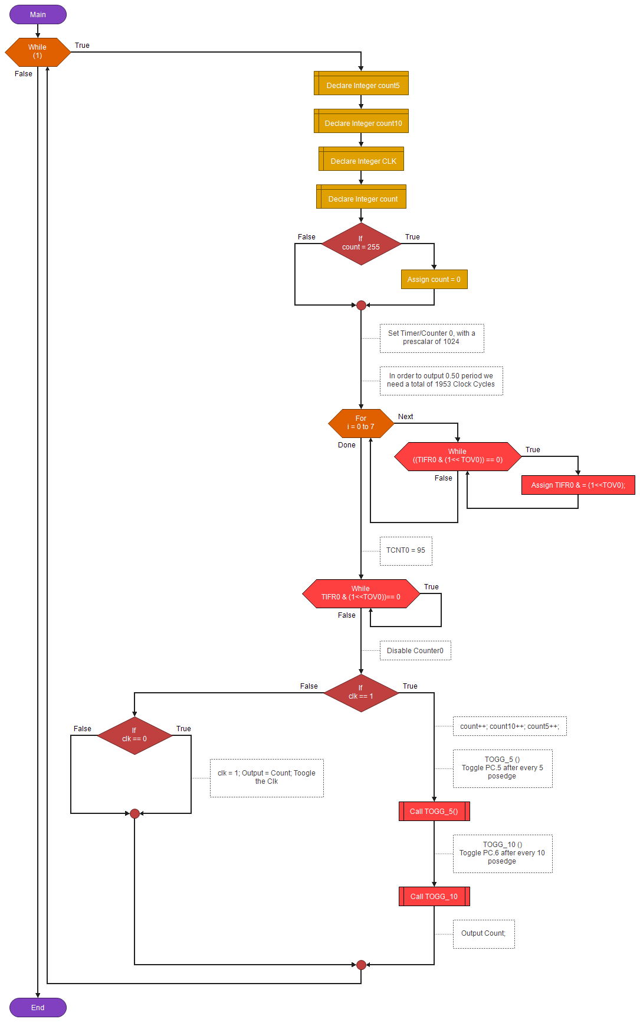

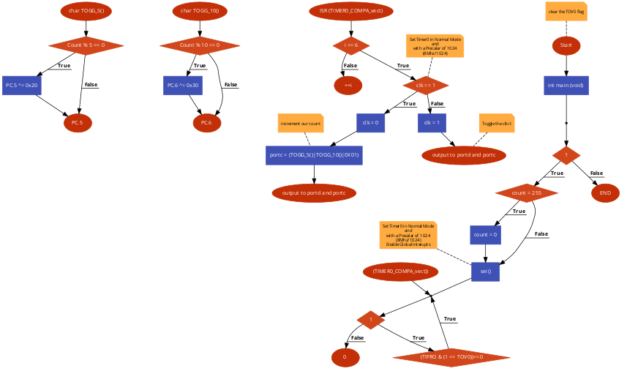

The flow chart above demonstrates flow of DA2_2 and DA2_4, as before I tried to design both snippets of code that were very similar; however, the main difference was the language. They both had three functions: char TOGG_5, char TOGG_10 and ISR(TIMER0_COMPA_vect).

**PART D: Schematic**

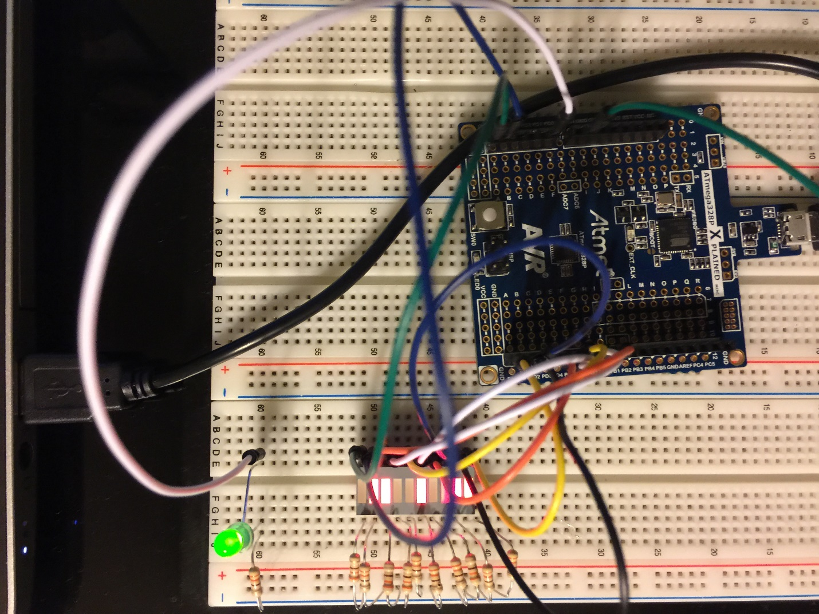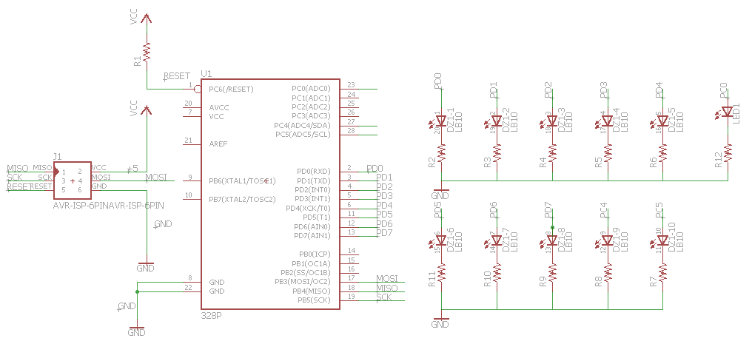

**PART E: YouTube Link**

URL: <https://www.youtube.com/watch?v=o1vD-zR6FNs&feature=youtu.be>